# CS 255 System Design Document

## UML Diagrams

### UML Use Case Diagram

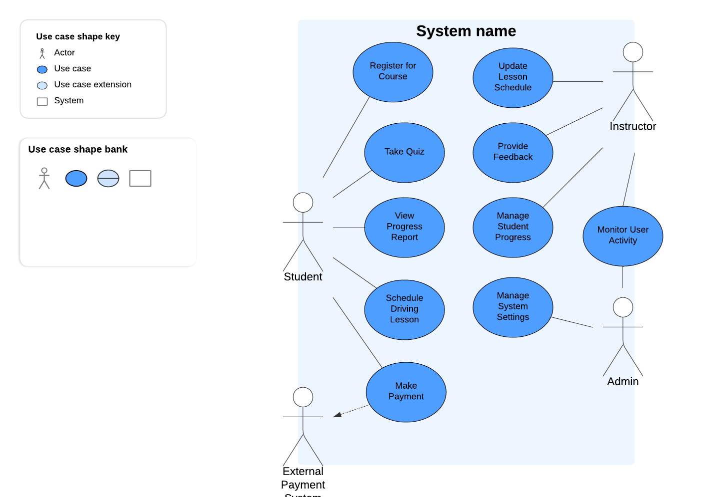

### UML Activity Diagrams

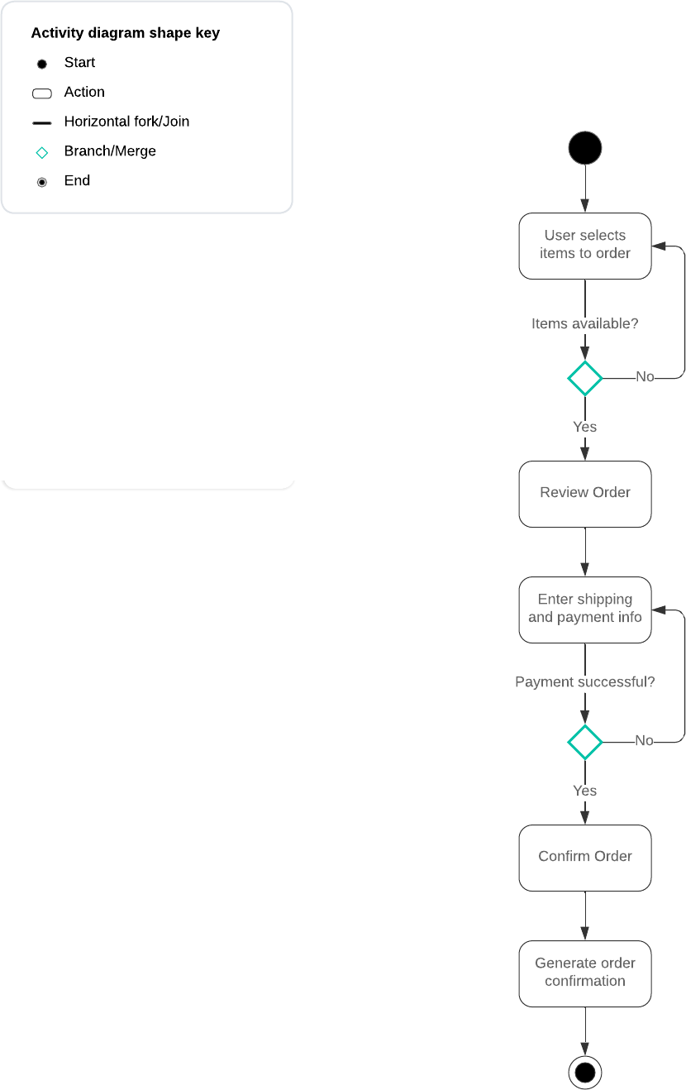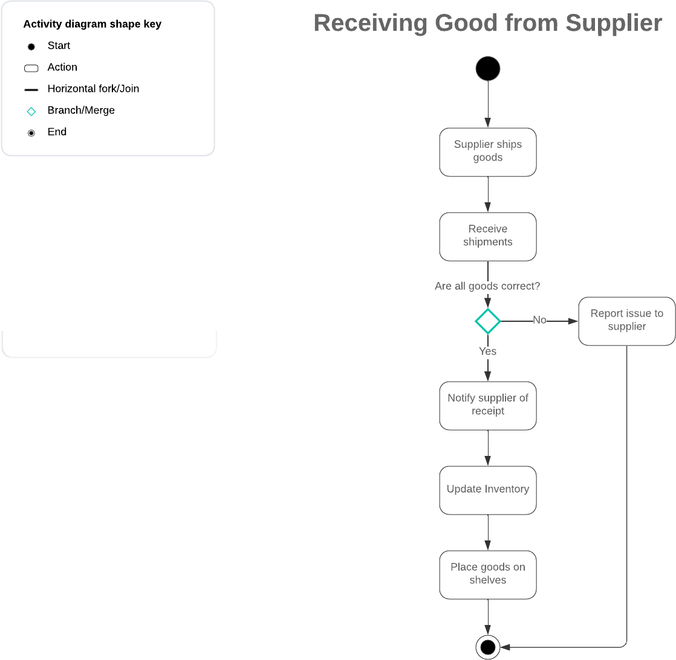

### UML Sequence Diagram

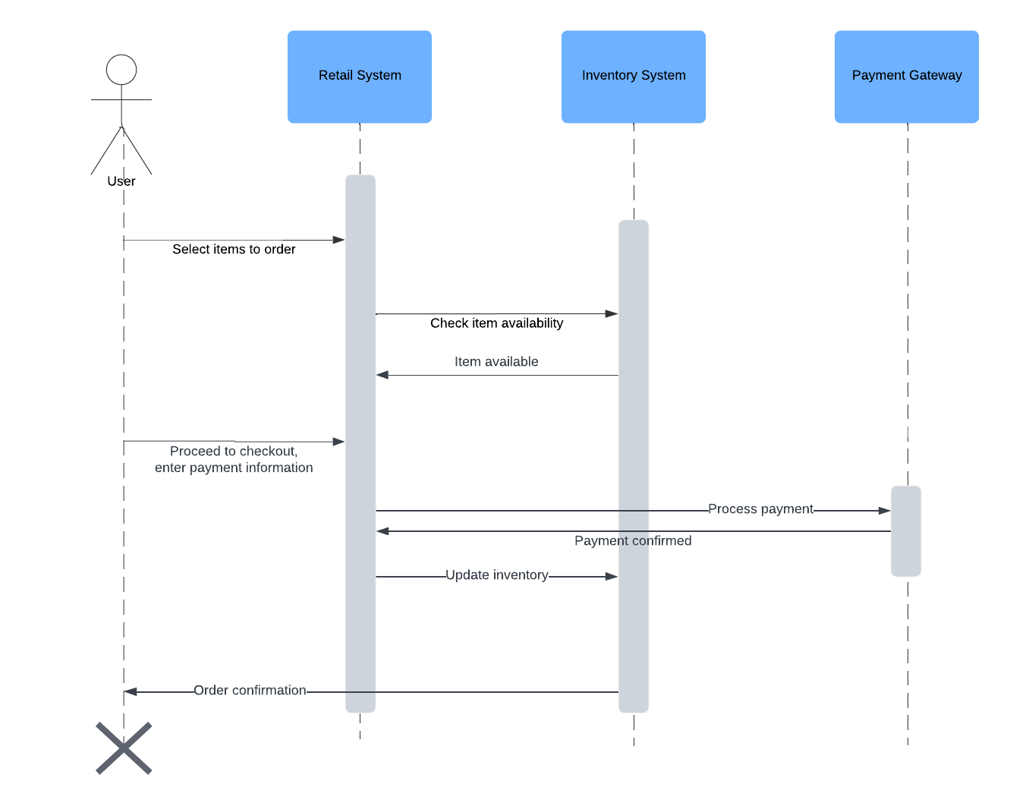

### UML Class Diagram

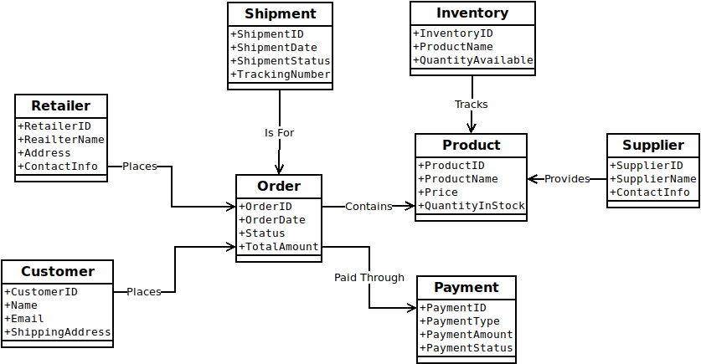

## Technical Requirements

### Technical Requirements for the Retail System

To implement the retail system described by the UML diagrams, several technical requirements must be addressed, including hardware, software, and infrastructure.

**Hardware:**

The system will require reliable server hardware to host the online retail platform, ensuring 24/7 availability for customers and suppliers. This server infrastructure should include sufficient CPU, memory, and storage to handle high traffic loads, large amounts of product data, and customer transactions. Additionally, database servers will be required to store customer information, inventory data, and order details. Redundancy measures such as backup servers and load balancers should be in place to prevent downtime. For point-of-sale (POS) systems within physical retail locations, the retailer will need terminals that connect to the main system for real-time inventory and order management.

**Software:**

On the software side, the retail system requires a robust e-commerce platform that integrates with inventory management, payment gateways, and order processing. The software should allow for scalability as the business grows and must be secure, especially for handling sensitive payment information. A relational database management system (RDBMS) like MySQL or PostgreSQL will be essential for managing structured data such as orders, products, and customer profiles. The system should also incorporate an inventory management tool that automatically updates stock levels based on order transactions. Additionally, APIs will be needed to integrate with third-party suppliers for real-time order fulfillment and shipment tracking.

**Tools:**

Development tools such as IDEs (e.g., Visual Studio or Eclipse) and version control systems like Git will be necessary to manage the system's codebase and facilitate team collaboration. For database design and management, tools like phpMyAdmin, pgAdmin, or SQL Workbench will be useful for administrators. Additionally, cloud-based platforms like AWS or Azure can provide development and deployment environments, as well as additional tools for scaling and monitoring the system. Lucidchart or similar diagramming tools will be useful in continuously modeling and updating the system’s design.

**Infrastructure:**

The system will need a secure and scalable cloud infrastructure, such as Amazon Web Services (AWS) or Microsoft Azure, which can provide the flexibility to scale up or down based on demand. Security infrastructure, such as firewalls, SSL certificates, and encryption mechanisms, will be critical to protect customer and payment data. For payment processing, integration with established payment gateways like PayPal or Stripe is necessary to securely handle transactions. Additionally, a reliable content delivery network (CDN) will ensure that the online retail platform loads quickly for users across different geographical locations.

In summary, this system will require robust hardware for hosting, reliable software for managing retail operations, and a cloud infrastructure capable of scaling with the business, all while maintaining stringent security and privacy protocols.